RX Form Training Guide

The RX Forms are a protected document and only allow for editing in the form fields and in the section for the surveyor’s description. The form fields are the gray and/or shaded areas in the document. Section 5501.31 of the Ohio Revised Code requires the conveyance instruments used by ODOT to acquire property must be approved by the Ohio Attorney General’s Office. No one may alter these forms without pre-approval of the Ohio Attorney General’s Office. When these forms are unable to accommodate a description being prepared please contact the appropriate District Office for assistance.

Form Fields
The Form Fields will either be a data entry field or drop down menu, and will allow users to enter data only in the sections of the document that are needed. When moving to the next form field the user can select the Tab Key or the Arrow Keys to maneuver through the form fields. Microsoft spell check cannot be utilized in form fields.

Note: Do NOT hit the Enter Key to advance to the next field. Only use the Tab Key or Arrow Keys to move between fields.

Entering Data into the Caption of the RX Forms

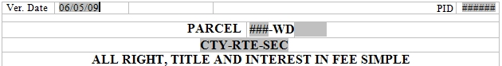
Start with the MM/DD/YY form field and enter the date the RX Form was prepared and/or completed. Then select either the Tab Key or the Down Arrow Key to advance to the next form field.

Enter the Project Identification Number in the ##### form field. Then select either the Tab Key or the Down Arrow Key to advance to the next form field.
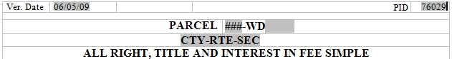
In the # form field, enter the parcel number of which the description will be describing. Then select either the Tab Key or the Down Arrow Key to advance to the next form field.
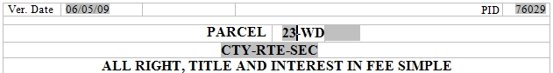
When multiple parcel identifiers of the same type are encountered in a contiguous ownership, enter the number in the Parcel Identifier form field. Then select either the Tab Key or the Down Arrow Key to advance to the next form field.
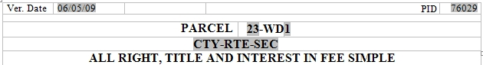

In the CTY-RTE-SEC form field, enter the County, Route, and Section. Then select either the Tab Key or the Down Arrow Key to advance to the next form field.
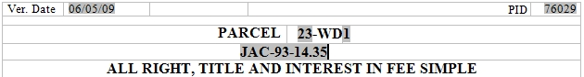

RX Forms with a V designation (a.k.a. LPA):

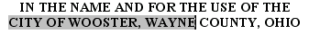
In the "NAME OF LPA AND / OR COUNTY"
form field enter the name of the LPA and/or county When acquiring from a City or Township include the words “City of “ or “Township of” prior to the city name and followed by the name of the county. Then select either the Tab Key or the Down Arrow Key to
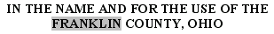
advance to the Surveyor’s Description.

RX 286 & RX 287 “Temporary Easement”:
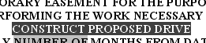
In the PURPOSE OF TEMPORARY form field enter the purpose for the temporary easement. Then select either the Tab Key or the Down Arrow Key to advance to the next field.
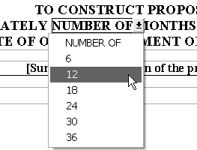
Click on the NUMBER OF form field, and select the number of months the temporary easement will be needed. Then select either the Tab Key or the Down Arrow Key to advance to the Surveyor’s Description.

RX 282 & RX 283 “Utility Easement”:

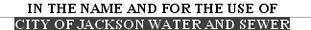
In the NAME OF THE UTILITY COMPANY
form field enter the name of the utility. (This form field does not appear in the RX 283). Then select either the Tab Key or
the Down Arrow Key to advance
to the next field.

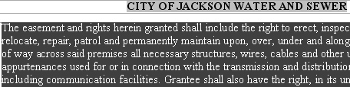
In the next form field which begins with the phrase THE FIRST PARAGRAPH describe the purpose of the take. Then select either the Tab Key or the Down Arrow Key to advance to the
Surveyor’s Description.
RX 290, RX 291, RX 292, & RX 293 “Property Right”:
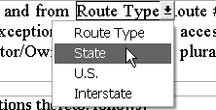
Click on the Route Type form field, a drop down menu will appear, select the appropriate Route Type “State”, “U.S.”, or “Interstate” from the drop down menu. Then select either the
Tab Key or the Down Arrow Key to advance to the next field.

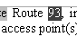

In the # form field enter the Route number. Then select either the Tab
Key or the Down Arrow Key to advance to the Surveyor’s Description.

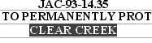
RX 300 Bank Protection:
In the NAME OF STREAM WITH BANK TO BE PROTECTED form field enter the stream name. Then select either the Tab Key or the Down Arrow Key to advance to the Surveyor’s Description.

The Surveyor’s description is where the surveyor’s description is entered. Each description shall be in accordance with the current Ohio Revised Code 4733 and 4733-37, all applicable County Conveyance Standards the Real Estate Policies and Procedures Manual, and applicable District guidelines.
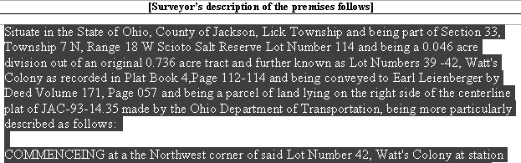

After this is entered the form will be complete and ready to print.

NOTE: Using the Select All or the Control All (Ctrl A) commands when copying a description from any word processing documents is discouraged. Often times, other document settings/formats are copied with the original document/description as well, creating formatting problems when pasted into the RX Form due to the courser going past the necessary text that is desired.

We recommend placing your courser at the beginning of the document and then selecting and dragging your mouse to the end of the displayed text only. Right click and select the copy command and then place copied text into the RX form. Selecting the extra spaces after the displayed text may include settings and formatting included in the document.

